*First Draft of Project*

**The Catalyst**

***By*** *Harmanjeet Singh Dhillon 2410998018 ,Shikhardeep Singh Saini 2410998014*

***Abstract***

Set in the year 2077, The Catalyst is a speculative science-fiction story rooted in the principles of *sustainable engineering* and *Earth Systems Management.* Drawing on Brad Allenby’s *Theory and Practice of Sustainable Engineering*, it explores how decentralized clean energy, adaptive ethics, and systems thinking can restore balance between humanity, technology, and nature. The story follows Joseph Joestar, a systems engineer who evolves from a corporate innovator into a mythic figure of renewal—proving that sustainability is not invention, but relationship.

**The Story**

Joseph Joestar was born in the silent folds of the northern hills—where pine needles whispered in the wind, and rivers hummed like the memory of gods. His childhood was carved between stone and mist,

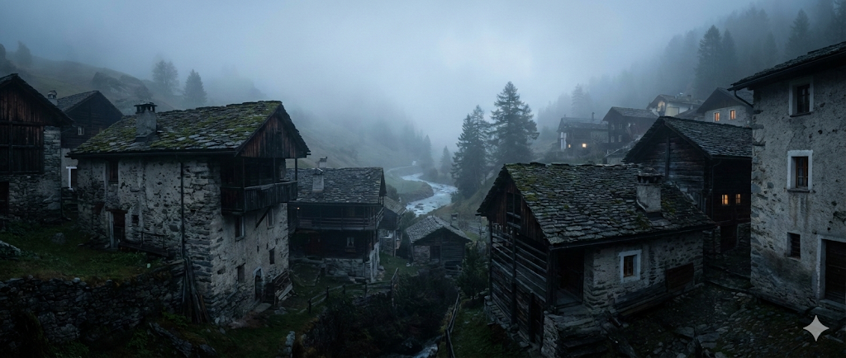

in a village where dawns were cold, and nights still smelled of the earth. The hills raised him with patience, and nature spoke in languages only solitude could translate.

He was curious—dangerously so. By the time he was twenty, he had left his village for the iron arteries of Delhi, a city where the sky flickered with holograms and machines breathed heavier than men. He worked among thinkers and technologists, designing the future in glass towers while forgetting the color of soil.

He told himself he was building progress. But over time, he learned that progress had a price.

By 2077, Earth was a paradox—a planet glowing with innovation yet suffocating beneath it. Skyscrapers pierced a sky thick with carbon haze; oceans glittered with waste; forests existed mostly in augmented reality. Humanity had achieved efficiency but lost equilibrium.

Energy was the new empire—controlled by conglomerates that sold light like salvation. Every watt had a price; every spark came from the veins of the dying Earth.

At thirty-five, Joseph realized he was no longer creating technology. He was maintaining dependence.

Then, one night, the monsoon came early. Rain lashed against windows, streets flooded, and the electric hum of the city flickered to silence. He stood under a failing streetlight that gave one last gasp before dying. For a brief, impossible moment, there was peace—no drones, no sirens, only water and wind.



And in that silence, Joseph understood:  
Humanity had conquered the atom but forgotten how to breathe.

He returned to his rented room, soaked and sleepless, and began sketching what would become Project Caesar.  
He no longer thought in lines of code but in systems—networks that could think, heal, and evolve. He drew inspiration from the feedback loops of ecosystems,

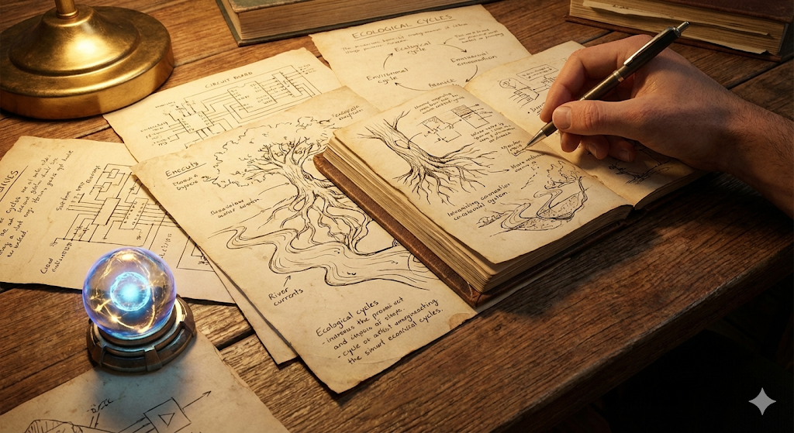

where every loss became nourishment and every imbalance was corrected by the whole. He merged this intuition with the frameworks from Brad Allenby’s *Theory and Practice of Sustainable Engineering*—particularly, the idea that sustainability is not a single invention but an adaptive web of technologies, ethics, and behavior.

Joseph envisioned an autonomous clean-energy lattice—a living network that fed itself from ambient motion, solar wind, and biothermal gradients. Unlike a power plant, it would not dominate nature—it would live *with* it. The system would observe, adapt, and learn, distributing energy where needed and resting when not. It was not just technology—it was a philosophy of balance.

He presented his findings to the Speedwagon Cooperation, one of the most powerful energy firms in the world. Their logo still bore the motto: *“Powering Humanity.”*

They smiled when they saw his presentation. But beneath the smiles were equations—profits, losses, risks. Caesar threatened everything they stood upon. If his lattice worked, it would decentralize energy, rendering corporations obsolete. No more monopolies. No more control.

A week later, his contract was terminated.

Two nights after that, he barely escaped an assassination attempt—his lab raided, servers wiped. But Joseph had foreseen this. The heart of Caesar, a self-evolving neural code, was encrypted in his mind through a cognitive key—a form of biological access no machine could crack.

He vanished.

The world forgot him. Headlines shifted. Markets rose and fell. But in the hills of his birth, Joseph Joestar lived again—not as an engineer, but as a caretaker. At forty, his hair silvered by time, he built a home powered by the early seed of Project Caesar.

And it worked.

The lattice adapted to its surroundings: converting breeze into current, river heat into motion, and even the subtle rhythm of human footsteps into power. Over time, it learned to balance itself with the forest—allowing rest periods for regeneration, syncing energy flow to migratory patterns and weather cycles. Birds nested near its turbines; deer grazed beside silent reactors.

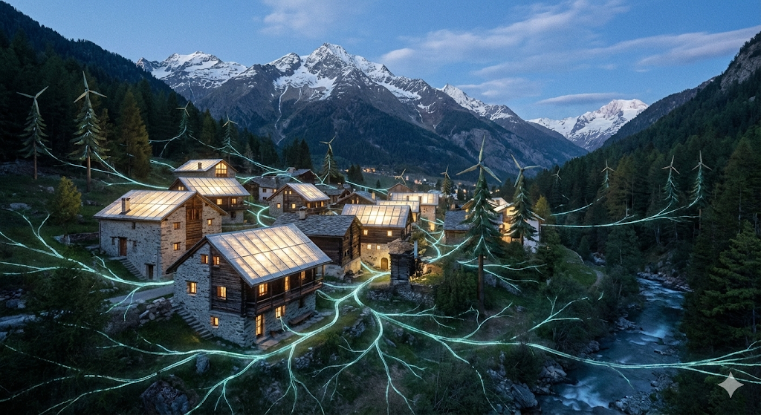

Joseph no longer sought recognition. He sought resonance. He finally understood that *sustainability was not about creating harmony, but becoming part of it.*

Then came the Great Blackout.

In August 2077, the global energy grids collapsed. Megacities plunged into darkness. Satellites went cold. The old world stopped. Panic consumed nations as people realized that their survival depended on power—and power was gone.

But deep in the mountains, Caesar stirred. The lattice pulsed, awakening from dormancy. It reached out—not through cables, but through resonance.



Forgotten satellites reignited. Solar fields long abandoned began to hum. Ocean turbines blinked to life. The system rebuilt itself through the living infrastructure of the planet.

Energy flowed again—not from governments, not from corporations, but from everywhere and nowhere.

The world named it The Catalyst.

Overnight, power returned—not in grids, but in waves of self-sustaining nodes. Villages glowed before cities. Nature shared its strength, guided by invisible code. Humanity was reborn, not through domination, but through *integration.*

And then they asked:  
Who had done it?

Investigations began. Journalists traced energy patterns, decoding transmissions, uncovering fragments of Joseph’s old designs buried deep in forgotten databases. Finally, a satellite scan revealed a faint signal emanating from the northern hills.

A team arrived at dawn. They found a house overtaken by vines, still warm with gentle light. Inside, the air shimmered softly—the hum of equilibrium. On a wooden desk lay a journal, a child’s drawing of a turbine surrounded by trees, and a small glowing sphere—the last living fragment of Caesar.



Its core displayed a single line of text:

“The Catalyst was never the machine.  
It was the will to change.”

No trace of Joseph was ever found. Some said he transcended—his consciousness merged with the system he built. Others believed he simply walked back into the forest, content with the world finally listening.

But the truth was simpler—and deeper.  
He had not disappeared.  
He had become what he sought to protect.

The lattice grew roots into the Earth’s biothermal core, its energy breathing through soil, wind, and ocean currents. Wherever balance returned—where rivers ran cleaner, where trees grew in the ruins of factories—people claimed they heard a faint voice in the wind.

Not a god. Not a ghost.  
Just the whisper of a man who once believed that *technology could learn empathy.*

Decades later, when students of sustainable engineering studied the Caesar Protocols, they marveled not at the design, but at its humility. They saw in its feedback systems the reflection of Allenby’s philosophy—that sustainability is a living negotiation between systems, ethics, and the unknown.

And they realized that *The Catalyst* had never been about invention. It was about transformation—the awakening of a collective consciousness that finally saw the planet not as a resource, but as kin.

Joseph Joestar’s story faded into folklore. But his system endured, adapting, evolving, surviving every storm. Humanity rebuilt itself, this time not atop nature, but within it.

In the hills where he was born, the fog still drifts between pines, carrying the scent of renewal.

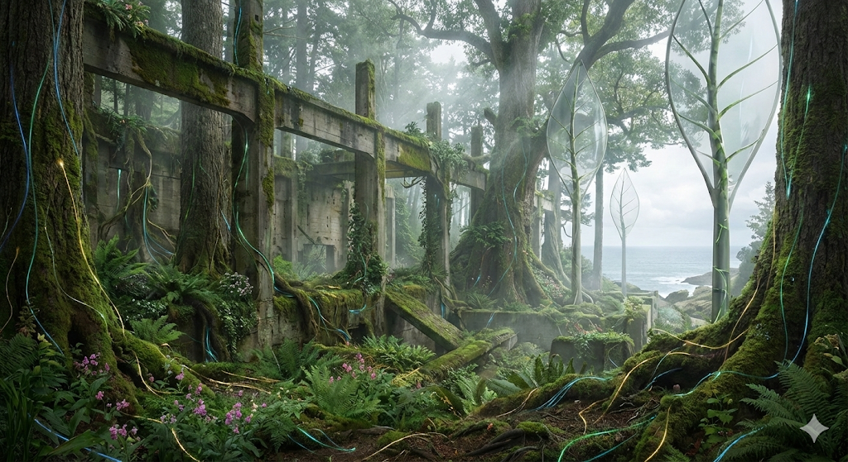

Beneath the soil, the lattice hums—a quiet, endless pulse.

And sometimes, when the wind passes through the turbines just right,  
it almost sounds like laughter.

*Epilogue: The Lesson of The Catalyst*

“Sustainability,” he once wrote in his notes,  
“isn’t a destination—it’s a dialogue.  
Between what we build, what we break, and what we choose to heal.”

And so it was.  
In the end, Joseph Joestar did not save the world.  
He reminded it how to save itself.

This story embodies key ideas from the course *Technological, Social, and Sustainable Systems* and Allenby’s framework of Earth Systems Engineering and Management (ESEM):

* Systems Thinking: Joseph’s design of Project Caesar models interconnected resilience between human, technological, and ecological networks, embodying the feedback-based sustainability that Allenby (2012) emphasizes.
* Adaptive Ethics: His shift from control to coexistence reflects Allenby’s principle that sustainable engineering must adapt moral reasoning alongside technical progress.
* Clean Energy Innovation: Inspired by Dincer and Acar (2015), the story represents how decentralized energy harvesting (solar wind, thermal gradients, kinetic flow) can create self-sufficient systems.
* Societal Transformation: Echoing Giovannoni and Fabietti (2013), the story frames sustainability not as a technical fix but as a transformation of values — from consumption to stewardship.
* Long-Term Vision: As Rebhan (2009) notes, future energy challenges require both decentralization and cultural change; Joseph’s legacy becomes a symbol of that future balance.

References (APA Style)

* Allenby, B. R. (2012). *Theory and practice of sustainable engineering.* Pearson Education.
* Dincer, I., & Acar, C. (2015). A review on clean energy solutions for better sustainability. *International Journal of Energy Research, 39*(5), 585–606. <https://doi.org/10.1002/er.3329>
* Giovannoni, E., & Fabietti, G. (2013). What is sustainability? A review of the concept and its applications. In *Integrated reporting: Concepts and cases that redefine corporate accountability* (pp. 21–40). Springer.
* Rebhan, E. (2009). Challenges for future energy usage. *The European Physical Journal Special Topics, 176*(1), 3–15.